­



Quick Snacks

USER MANUAL

**Group Members**

|  |  |
| --- | --- |
| **Names:** | Shaikh Muhammad Taha (1283664)  Hassan Ahmed (1283654)  Ammar Ahmed (1283653)  Adnan Iqbal (1283670) |
| **Batch Code:** | 2010B4 |
| **Faculty:** | Sir Saad Bin Shafi |
| **Coordinator:** | Miss Maha |

1. **Introduction**
   1. **Problem Statement**

Even though snacking has developed a "bad image," snacks can be an important part of your diet. They can provide energy in the middle of the day or when you exercise. A healthy snack between meals can also decrease your hunger and keep you from overeating at meal time.

We are looking forward to develop a website “Quick Snacks” which will include quick snacks recipes

The website which they demand is supposed to provide user friendly environment and navigation. The important menu must be stated in the top section of the webpage. Also, a decent look out and color combination is expected.

The website is to be developed for the Windows Platform using HTML5, JavaScript and Geolocation. The site should work well in all leading browsers including Chrome, IE, Firefox etc.

**Requirements**

The Web site is to be created based on the following requirements.

1. Home page with suitable images /offers should be provided. Navigation links must be included
2. The user should be able to browse through various categories
   1. Healthy Snacks
   2. Snacks for kids
   3. Easy on stomach snacks
   4. Smoothies

User can add more related categories if wish to.

1. When user selects any of the category, the various items should be listed and further if user selects any particular item, details of that item should be displayed. Details should include
   1. Ingredients along with proportion
   2. Detailed recipe
   3. Estimated time taken to prepare
   4. Approx. quantity (e.g.: can serve 2, can serve 4 and so on)
   5. Calorie and related information
2. Site should include reviews/feedbacks section on various snacks
3. There should be a separate section providing information on certain items needed for particular snacks as where it can be best purchased.
4. Gallery should be available which will showcase the small celebration videos/images
5. Contact us page: contact us details with location should be displayed using Geolocation API (e.g., Google Maps).
6. Also, each link must be properly hyperlinked, images must be used wherever necessary.
   1. **Purpose**

The Purpose of our website is to provide info to the user about the Quick Snacks. The website also gives a contact us and locate us page to the user where he/she can find info of our locations and also give feedback.

* 1. **Overall Description**

The website is divided into 4 different pages:

1. Home
2. Categories

* Healthy Snacks
* Snacks for kids
* Easy on stomach snacks
* Smoothies

1. Gallery
2. Contact us

Snacks are further categorized into 4 distinct categories with complete details divided as (Healthy snacks, Snacks for kids, Easy on stomach snacks and Smoothies)

Each page contains the navigation bar that has hyperlinks to different pages. At the bottom of every page there is footer that contains basic details. At the very bottom there are linked to our pages.

* 1. **Basic Requirements**

4GB RAM

250 Hard Drive

Chrome, or Firefox

**1.5 UI**

**Home**

Our homepage has summary details of the overall website with proper navigational links

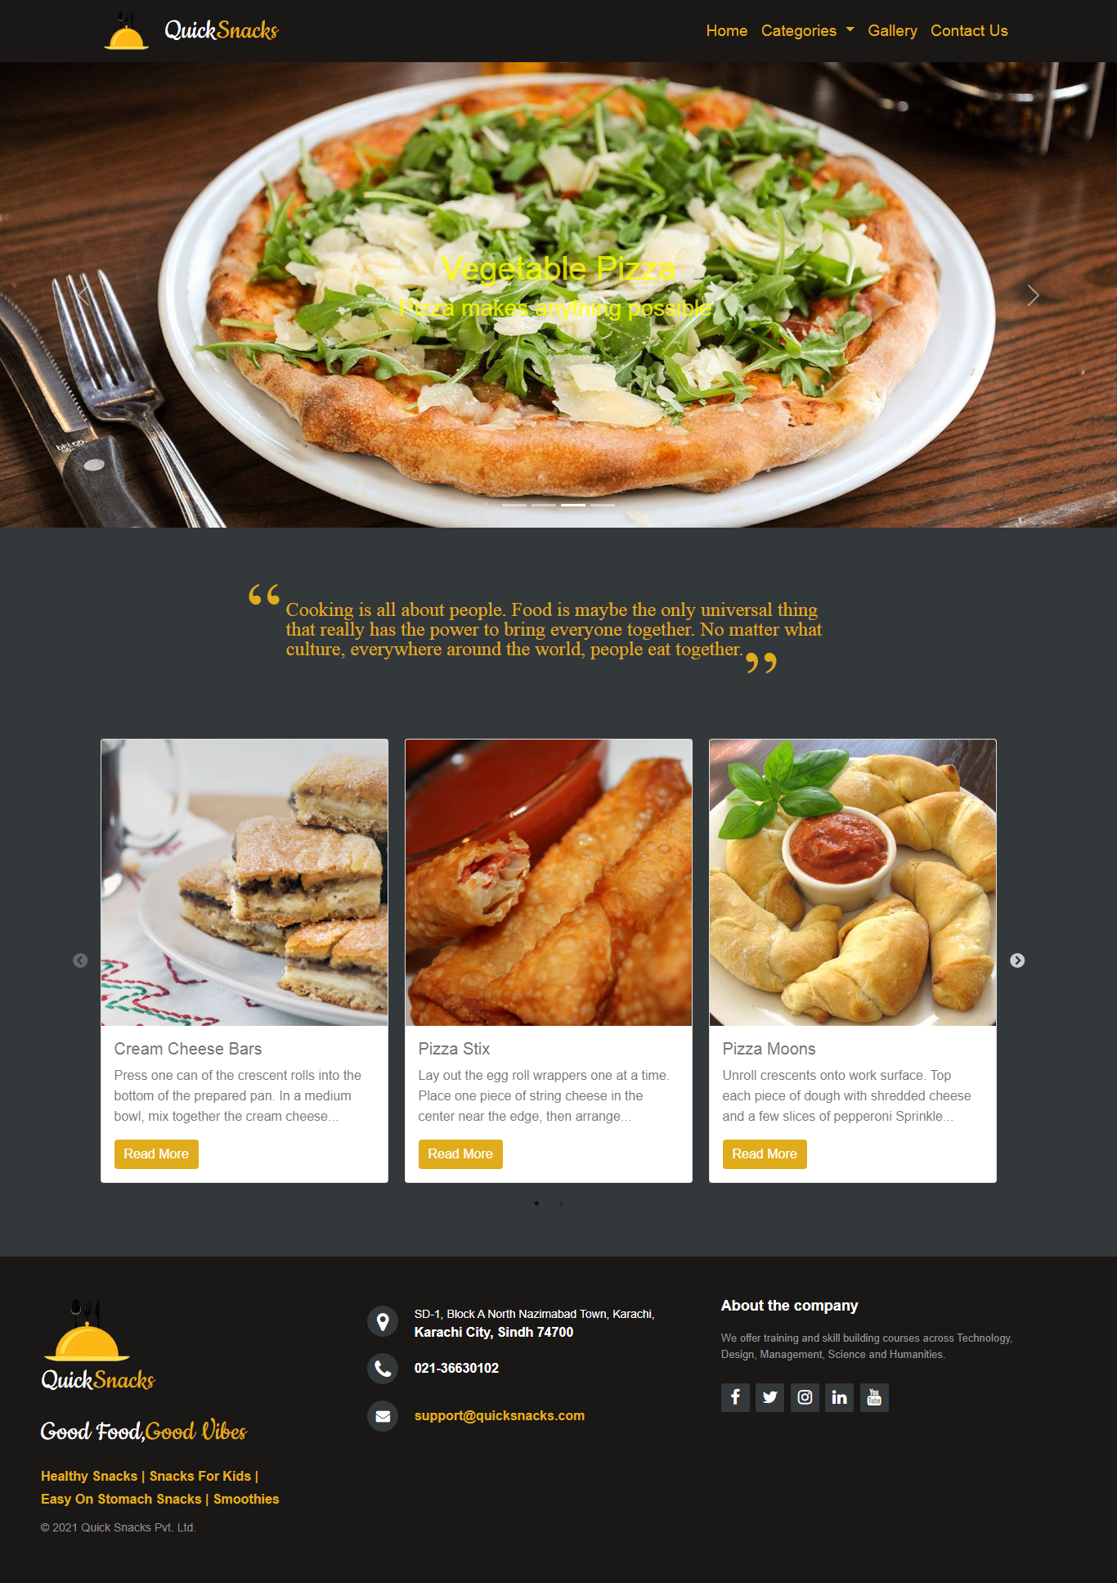**Gallery**

This page contains the gallery of various types of snacks of Pakistan 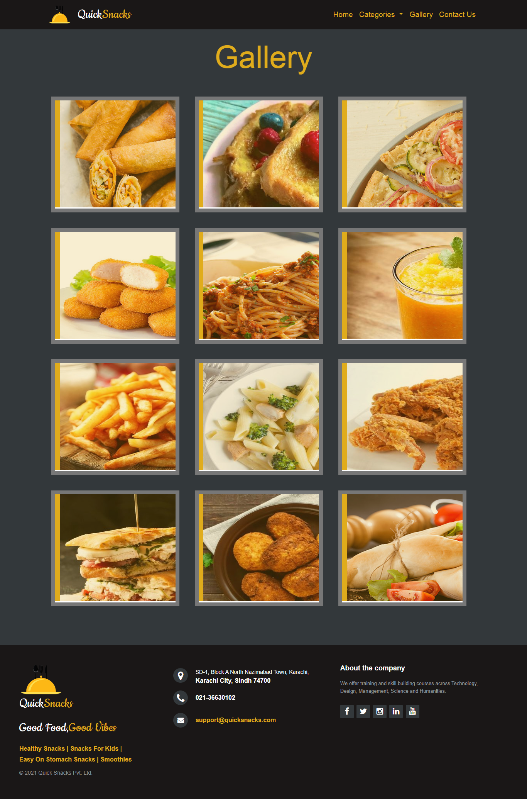

**Snacks**

Snacks are categorized into 4 various types of snacks of Pakistan which are further discussed into 6 modals

**Heathy Snacks (Main)**

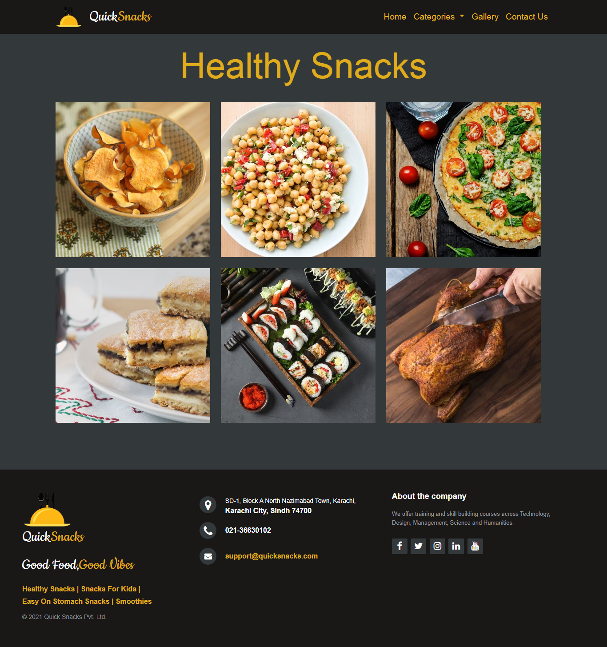Contains the main details of healthy snacks

**Snacks for kids**

Contains the details of snacks for kids

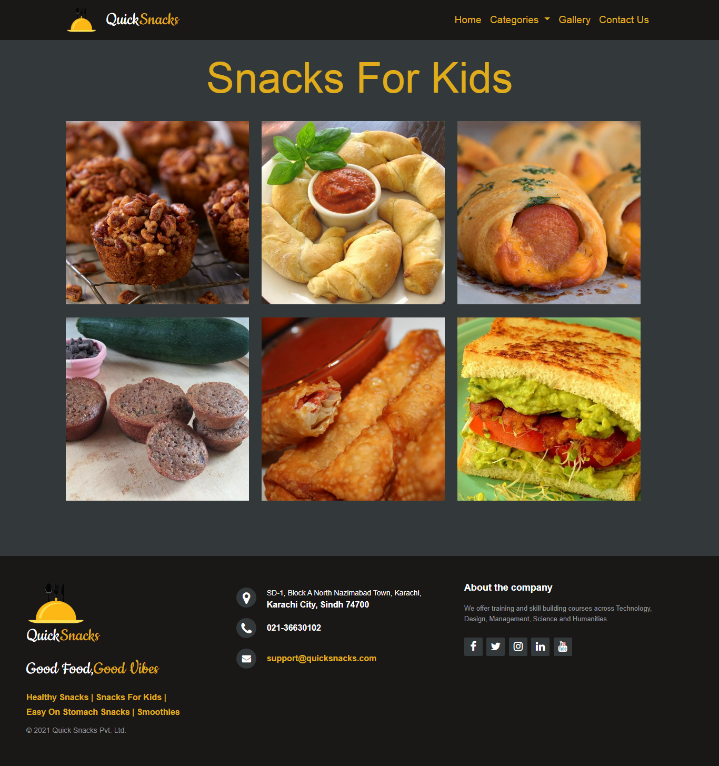

**Easy on stomach snacks**

Contains the details of easy on stomach snacks

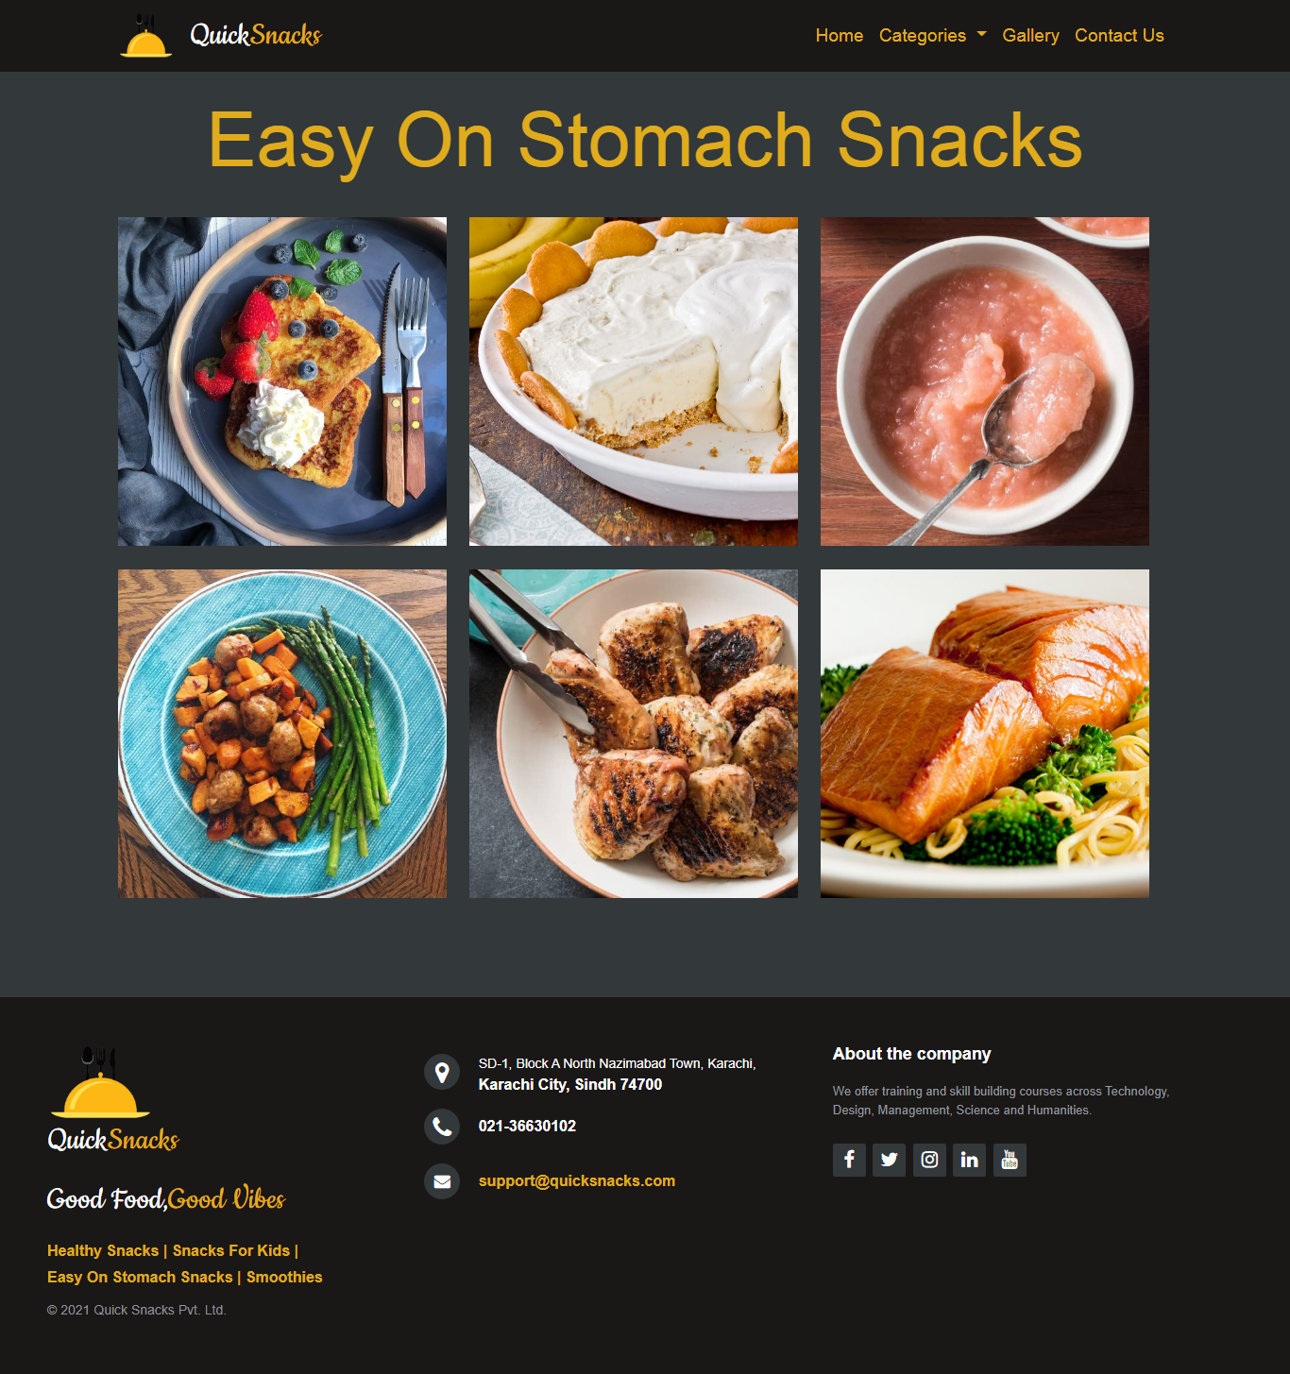

**Smoothies**

Contains the details of smoothies

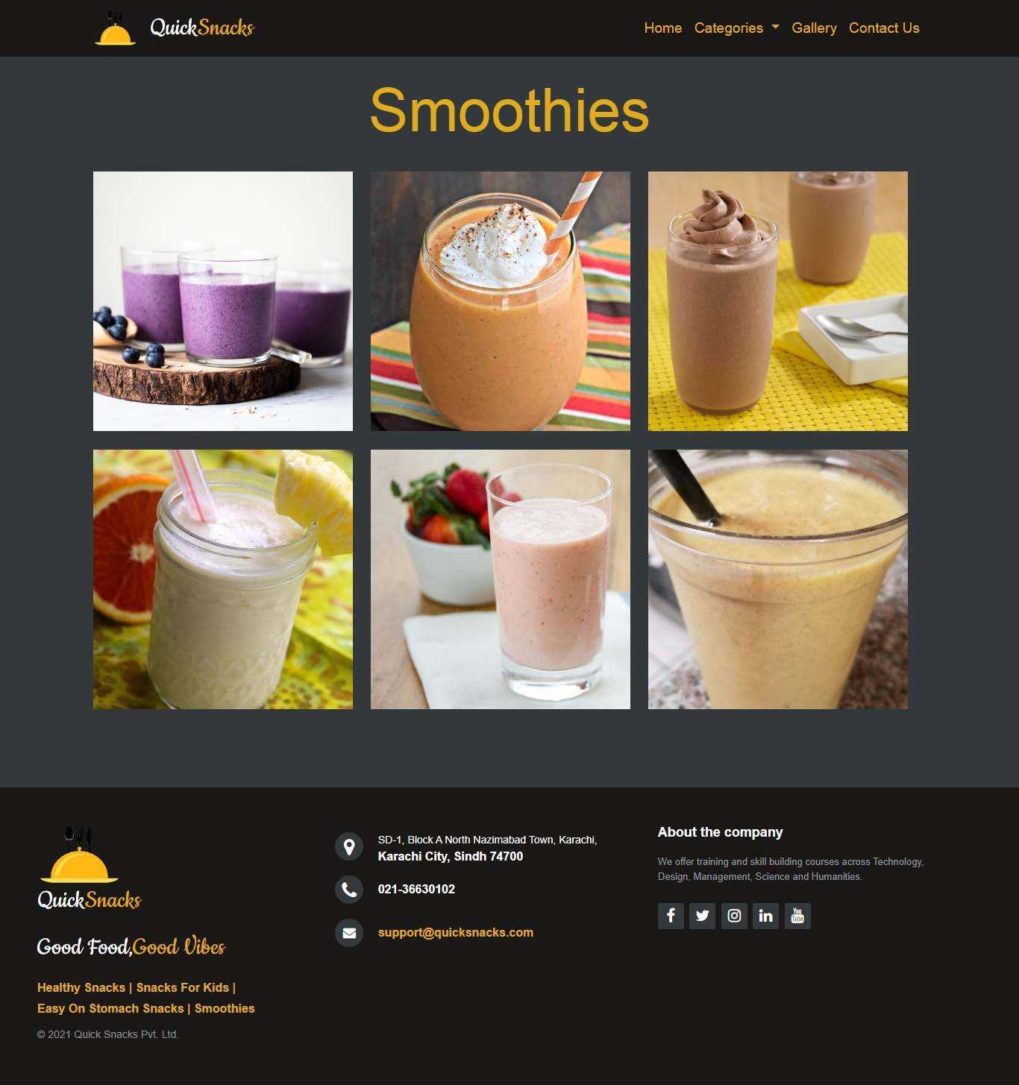

**Contact us**

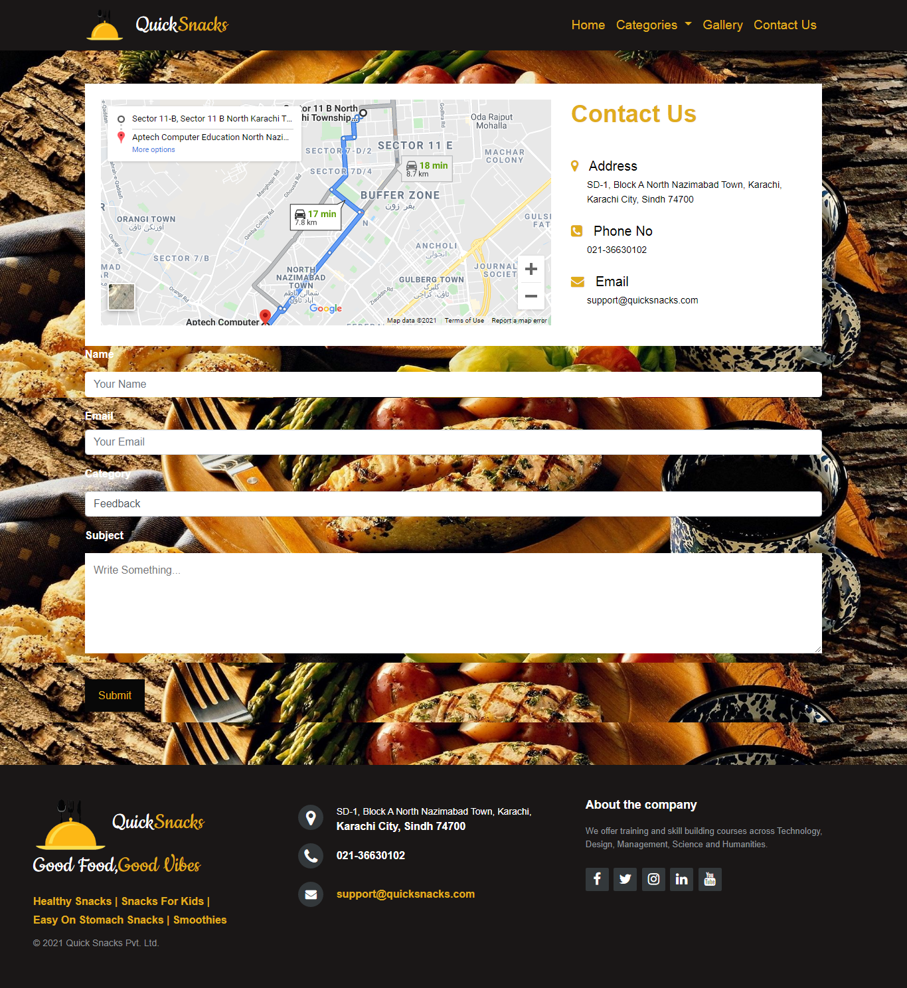This page contains the details, location and feedback form